**Introduction to Computer Programming in C++**

**What is Programming?**

* The Sequential set of instructions provided to a computer to perform a certain task.

**What is Computer Programming?**

* The process of implementing and developing various sets of instructions to enable a computer to perform certain tasks.

**What is C Language?**

* C is a programming language.
* Made in 1970.
* Which is supported by UNIX Operating system
* It is a procedural programming language.

**What is C++ Language?**

* C++ is a programming Language.
* It is the extension of C language.
* Made in 1979.
* By Bayern Stroustrup.
* It is Object oriented programming Language

**What are Header Files?**

* Header file is source file
* That contains the definition of library function

**What is Library function?**

* Library functions are the functions which are predefined in C++

**What is using namespace std?**

* It is used for input and output stream
* We can say that “cout is predefined function which is defined in header file iostream in located in standard namespace”

**What is main Function?**

* It is written as main()
* (), These brackets represent function
* **What is return 0?**
* Return means to give back
* 0 is the value which is returned to main function
* Void data type didn’t take any value in return

**What is Constant or Literals?**

* Any value that cannot be change
* Defined by const Keyword
* Written as => const datatype name = initialization
* It is initialized at the time of declaration

**What is Variable?**

* Variable makes a space in memory
* Or we can say that it is space or a container, in which we can store any value
* Variable can be change

**What are Keywords?**

* The words that are used by the language and carry special meanings are called keywords.
* Keywords are predefined reserved words used in programming.
* Keywords are part of the syntax, and they cannot be used as an identifier.
* For example: int salary; Here, int is a keyword that indicates ‘salary' is a variable of type integer.
* Keywords appear in blue in Visual C++.
* Do not use keywords as variable, identifiers, and constant names

**What are Identifiers?**

* An identifier is a name that is assigned by the user for a program element such as variable, functions and structures.
* Identifiers must be unique: They are created to give unique name to a entity to identify it during the execution of the program.
* For example:
* int length; => Here length is identifier
* char n=‘a’; => Here n is identifier
* Identifier must be different from keywords. Better to have a meaningful name for the identifier.

**Compiling C++ Program**

* C++ compiler translates the source program with .cpp
* extension into machine code called object code.
* Object code is stored in the new file with .obj extension.
* Object code is then linked to libraries
* After linking, an executable file with extension .exe is
* created.
* The executable program is then executed.

**Stages of compiling a C or C++ Program**

* Preprocessor
* Compiler
* Linker

1. **What is a preprocessor?**

* The first stage of compilation is called preprocessing.
* The C preprocessor modifies a source file before handing it over to the
* compiler, like defining constants # define and including header files i.e. #
* include<>.
* The preprocessors are the directives, which give instructions to the
* compiler to preprocess the information before actual compilation starts.
* All preprocessor directives begin with #

1. **What is compiler? (Making the object file)**

* After the C Preprocessor has included all the header files, the compiler
* then COMPILES the program.
* Compiler changes the C source file with .cpp extension into an Object
* code file with .o extension.
* The object file contains the binary version of the source code

1. **What is Linker?**

* The job of the linker is linking together a bunch of object files(.o files) into a
* binary executable.
* The file created after linking is ready to be loaded into memory and
* executed by the system

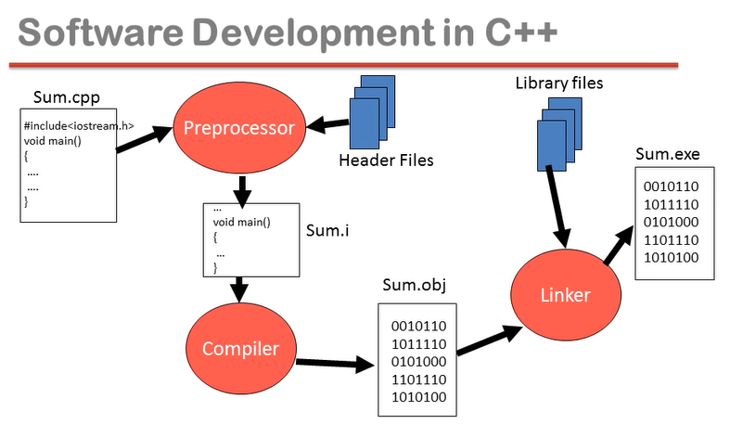

**What is declaration?**

* It means to declare any variable
* Example: int a; void c;

**What is initialization?**

* It means to give any value to declared variable
* Example: int a=10; void c=15;

**Cout in C++**

* It is known as Console output
* Uses << operator
* Known as insertion operator or put to operator
* Anything will be written in “”
* Statement ends with semicolon.

**Data Types in C++**

**What are the different data types in C++?**

* Following are different data types
* Int => int
* Void => void
* Float => float
* Double => double
* Boolean => bool
* Character => char

